# Motivation

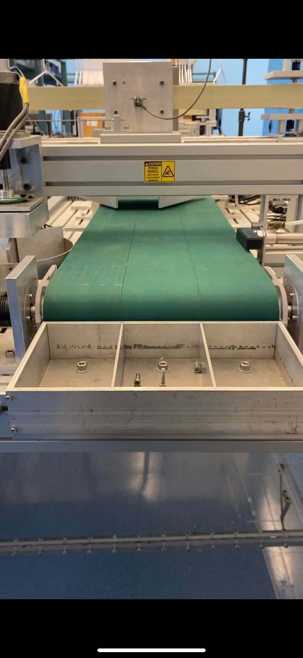This experiment is intended to de-risk a concept for a dispensing mechanism that will be a part of our automated retail machine. The concept I have designed is a simple conveyor belt, similar to the one we have in the Mechatronics Undergraduate Laboratory. The function of the conveyor in our product is to hold and dispense a range of small to medium-sized toys. The question however that has been brought up by our engineering instructor Konrad Walus is: how will we guarantee that the toys will fall to the retrieval area correctly after being “dispensed” by the conveyor? The term correctly refers to the toy not getting stuck or not getting damaged in the fall. This depends on a few factors including:

* The linear velocity of the conveyor
* The size, weight, and packaging of the toy
* The size of the open area that the toy can fall through, and the layout of the other levels of conveyors and toys

There are many variables that can be changed in this system; but first, the dynamics of the conveyor and toy trajectory need to be better understood. I have done a rough analytical analysis of the falling trajectory but as we know, models are not perfect. Therefore I propose the following experiment.

# Proposed Experiment

The experiment is relatively simple. I would like to measure the horizontal displacement of the toy and the toy’s angular displacement about its own axis after leaving the conveyor. The sample toy box will be a 6x8x4 inch cardboard box with some weight inside ranging from 150-450 grams. I have shown below my understanding of the system dynamics but, uncertainties like the front of the box starting to fall because of the radius of the sprocket on the conveyor, and at which point it will be released based on the friction force between the toy and conveyor belt holding the toy on the conveyor, make me doubt my model and therefore need to be tested.